W082439351_20383.docx
by Pedro Reno

Submission date: 21-Mar-2022 02:28PM (UTC+0800)
Submission ID: 1789021254
File name: W082439351_20383.docx (26.45K)
Word count: 540
Character count: 2887

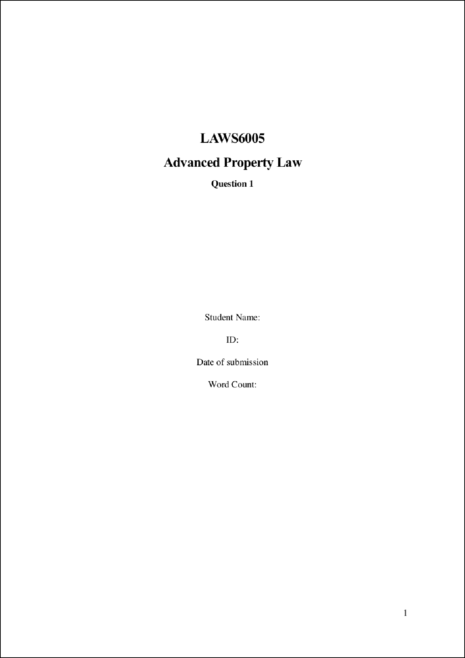

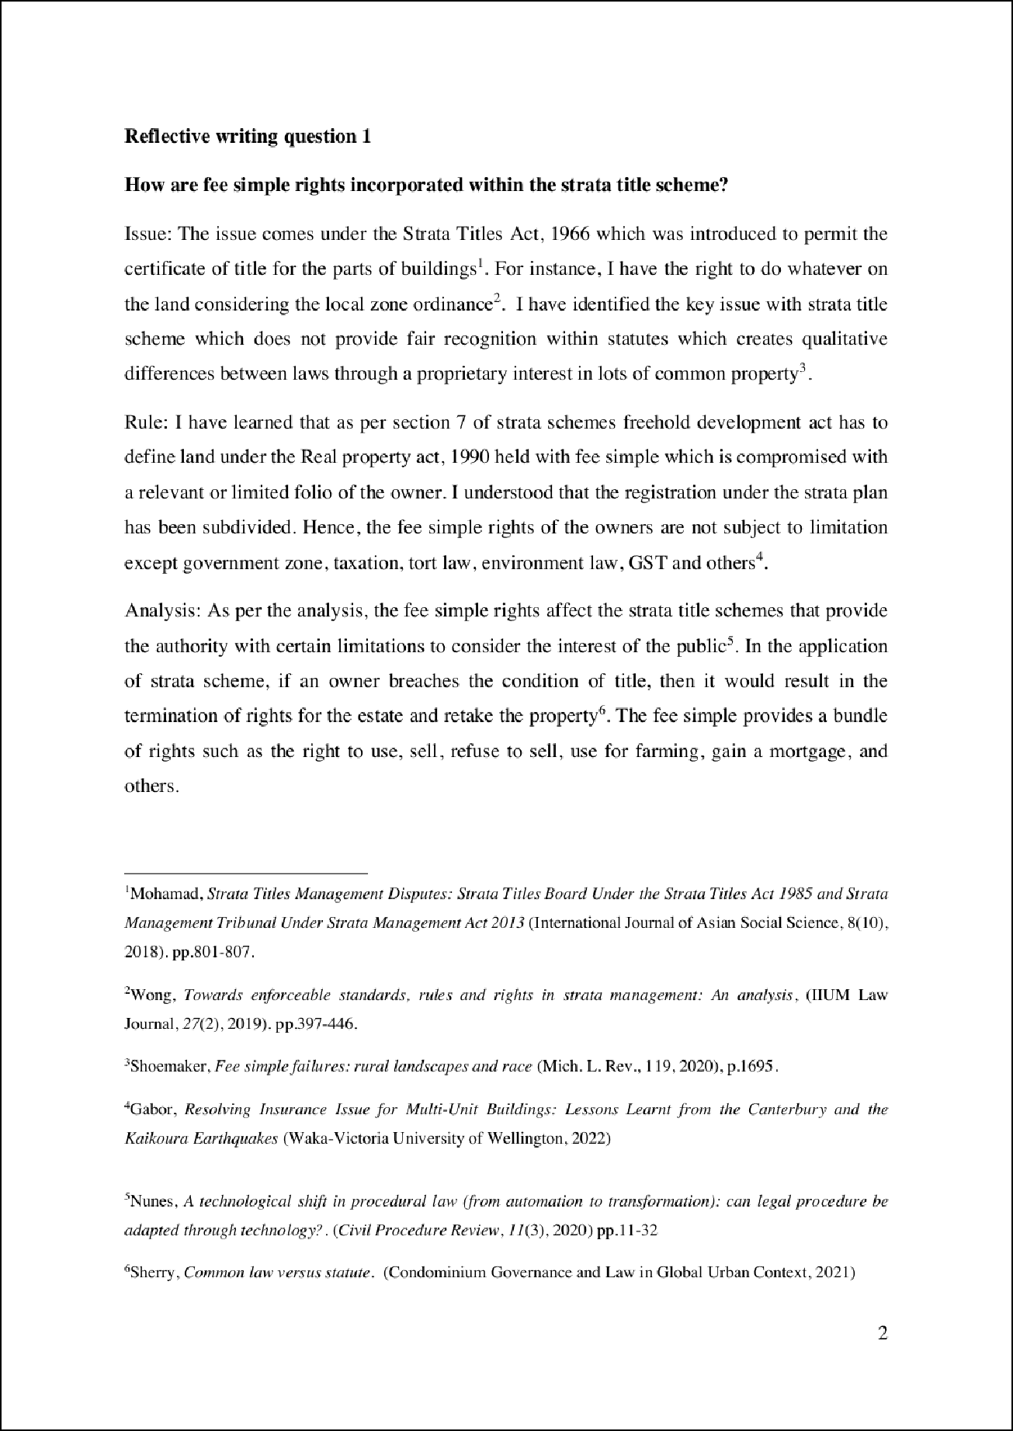

5

4

2

6

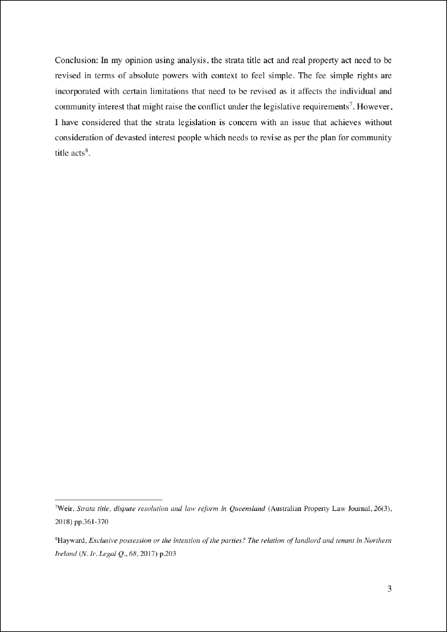

3

1

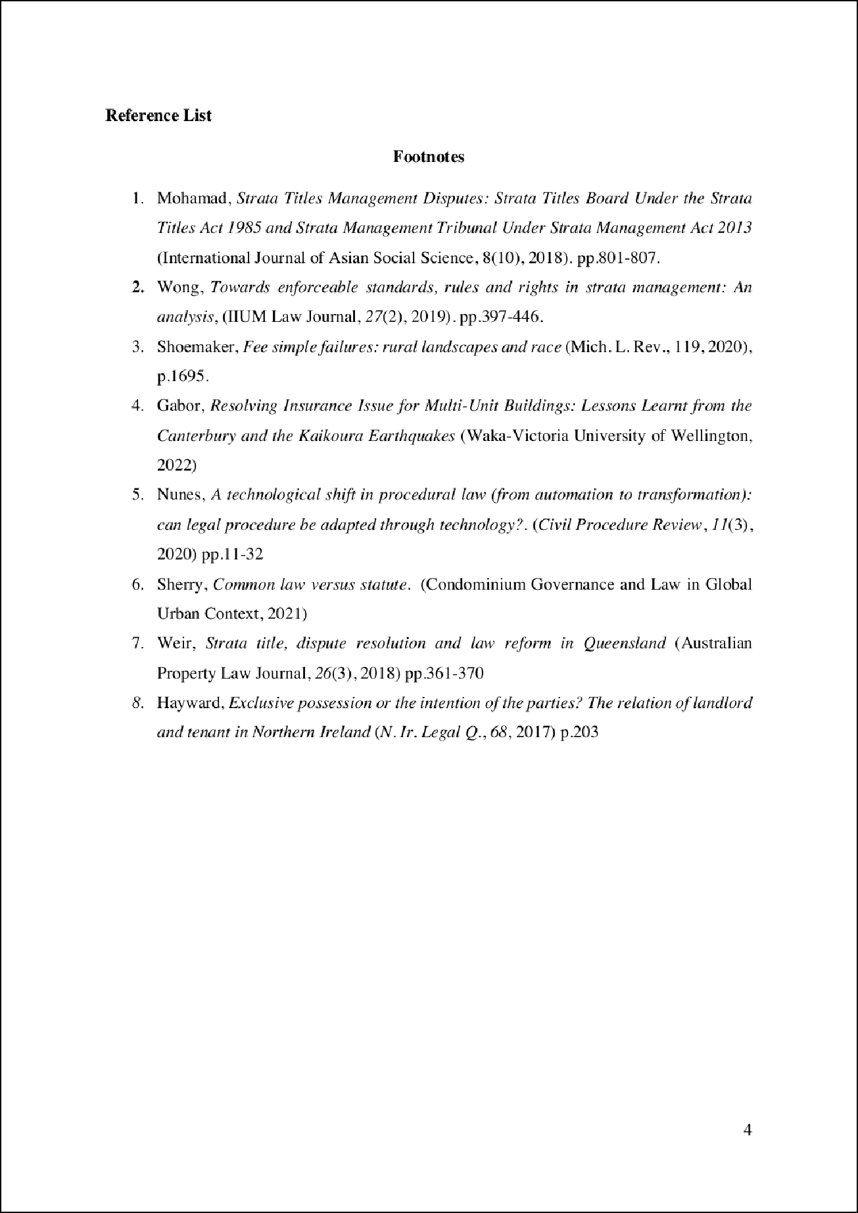

W082439351_20383.docx
22
ORIGINALITY REPORT

%
SIMILARITY INDEX
17%
INTERNET SOURCES
3%
PUBLICATIONS
18%
STUDENT PAPERS

PRIMARY SOURCES
1 Submitted to Kent Institute of Business and Technology
Student Paper
5%
4

Submitted to University of Kent at Canterbury
Student Paper %
2
4

Submitted to CECOS College London
Student Paper %
3
3

openaccess.wgtn.ac.nz
Internet Source %
4
3

econpapers.repec.org
Internet Source %
5
2%

6 Submitted to North East Surrey College of Technology, Surrey
Student Paper

Exclude quotes Oﬀ Exclude bibliography On
Exclude matches Oﬀ

